Contact:
Robert Duggan
rduggan@ipzusa.com 917-243-3406
FOR IMMEDIATE RELEASE: 10/13/22

Rutgers Star Cliff Omoruyi Partners With 16 Handles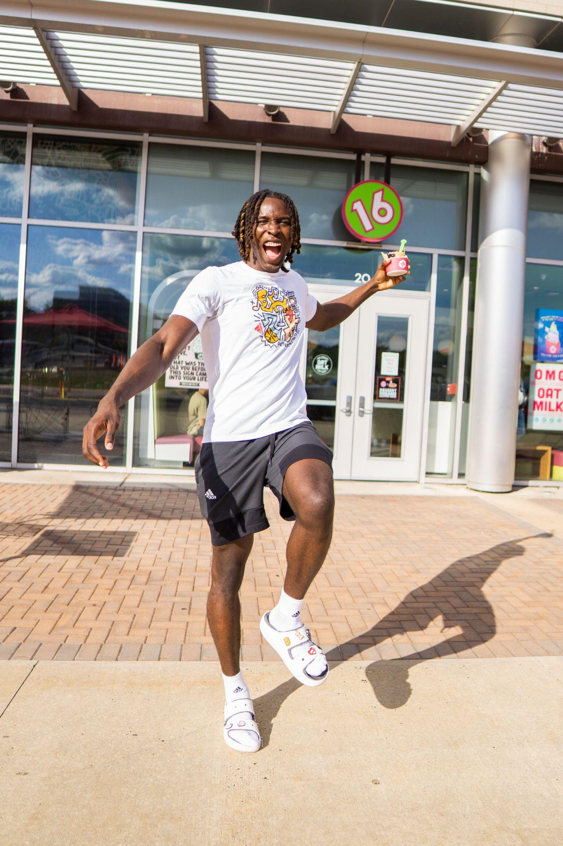

NEW YORK, NY AND TEWKSBURY, NJ (October 13, 2022)- 16 Handles, New York City’s #1 soft serve & dessert brand, has decided to team up with Cliff Omoruyi, the #1 dunk artist in college basketball.

Founded in 2008 as the first self-serve frozen dessert shop in New York City, 16 Handles has grown to become one of the most recognizable dessert chains in the Northeast and beyond. The brand has locations throughout New Jersey, including one on Rutgers University’s Livingston Campus.

"We're proud to make Cliff 16 Handles' first NCAA athlete partner,” said Neil Hershman, CEO of 16 Handles. “We admire his success on and off the court with his leadership, academic discipline, and community involvement. This partnership is especially sweet given Cliff is the star center at Rutgers University—the home to 16 Handles' first on-campus store location, and because it helps us to support community programs via the Salvation Army."

Omoruyi, a rising junior at Rutgers University, led NCAA Division 1 in dunks last season and is set to be the focal point of the Rutgers offense this season. Cliff continues to have a strong impact within the Rutgers & New Jersey communities both on and off the court, and this partnership will help the big man promote both.

This summer, he has volunteered as a counselor at the “Books & Basketball” program at the Salvation Army’s Newark West Side gym. 16 Handles will make a contribution to the Salvation Army as part of the relationship.
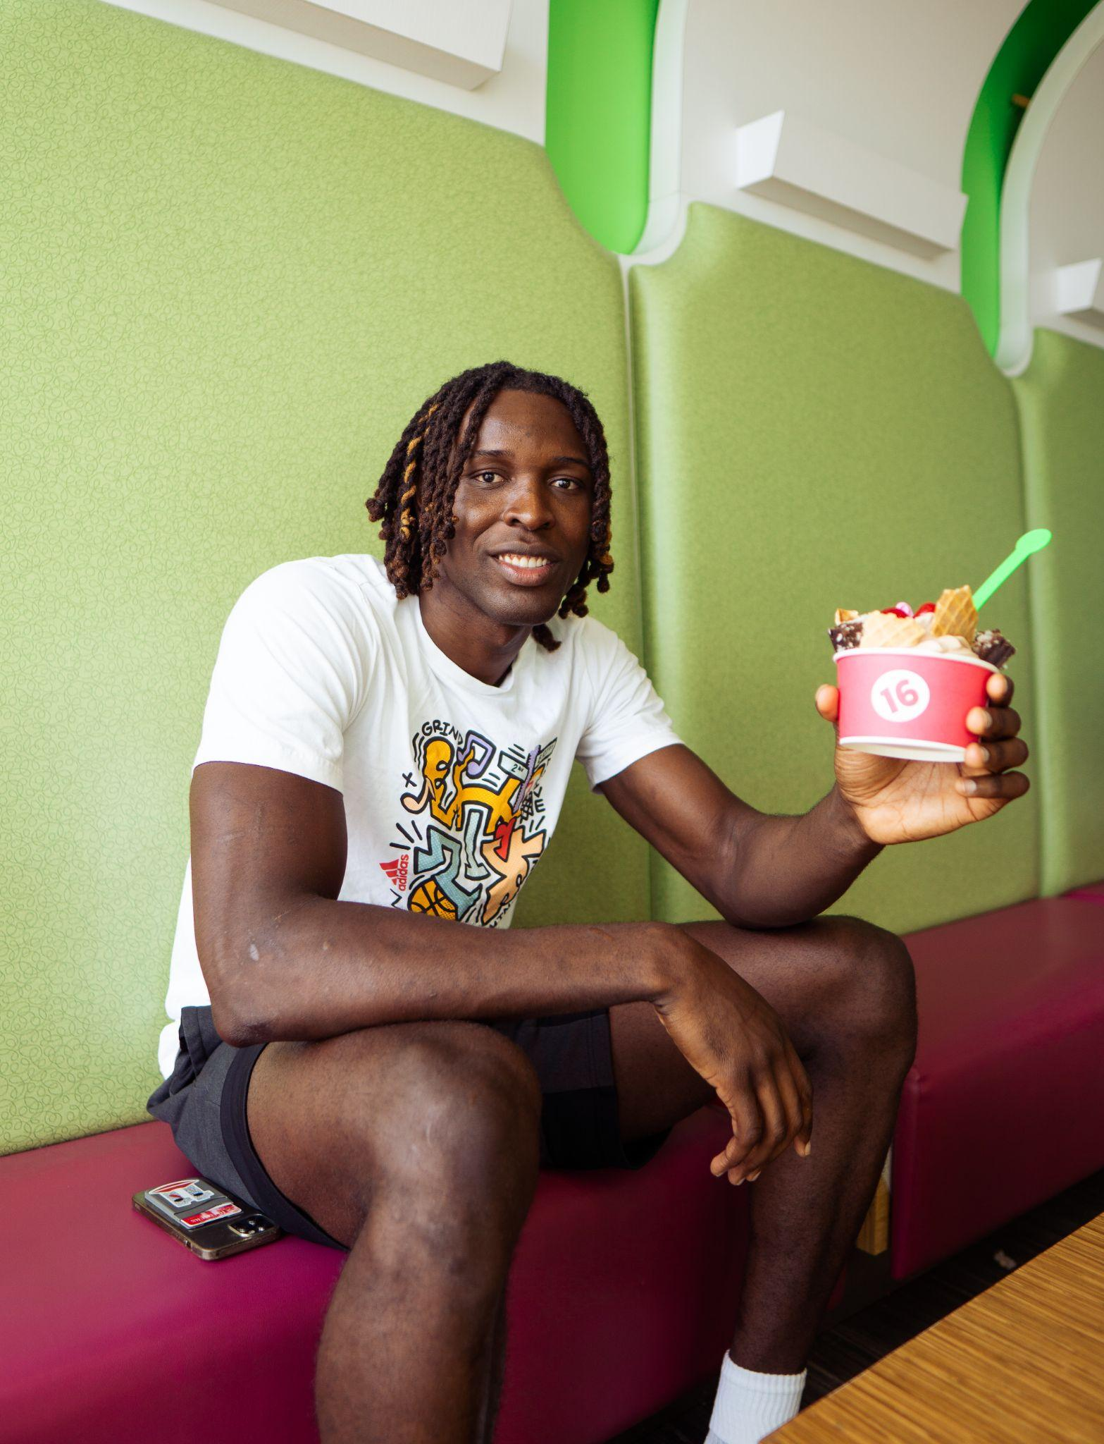
As Cliff prepares for the upcoming season and returns to campus for his junior year, he will take his first step into the world of NIL partnerships with 16 Handles. Big Cliff will promote the 16 Handles brand on social media and plans to develop a “signature sundae” with the company.

“I smile every time I see a Rutgers student on campus enjoying a 16 Handles sundae,” said Cliff. “Now, I’ll smile a little brighter!”

Along with social media promotion, Omoruyi will make an appearance at the 16 Handles location on the RU campus this semester, where he will share his signature sundae & interact with his fans as part of a semester tip-off event.

About 16 Handles: 16 Handles opened its first store in Manhattan’s East Village in 2008, becoming the first self-serve frozen yogurt shop in New York City. Since then, the brand has expanded to over 30 locations with a menu that includes frozen yogurt, ice cream, vegan soft serve, endless toppings, drinks, and other treats & snacks. Each shop’s full menu is available in store and via the 16 Handles app. In addition to creating irresistible desserts, 16 Handles works closely with local and national organizations in partnerships and fundraisers. For more information, visit 16handles.com.

About IPZ: IPZ represents clients in sports, media, and entertainment, providing management, contract negotiations, consulting, public relations and marketing communications support. The company, an alliance with Zito Partners, is built on the integrity of its professionals, maintains a family focus, and provides whole life solutions for its clients. For more information, visit www.ipzusa.com

